**About DHA Quetta Website Designing**

The outline of the website should show its hospitality and level of trust it has to offer customers. We have some examples/suggestions what the website should include.

**Mission and Vision Statement**

Starting off with our mission to achieve through DHA and forecasted vision.

***(Navigation Header) Suggested behavior***

* Loads with a pictorial picture with Text on picture as scrolled down. (Text may include a persuasive/bold slogan)
* While scrolling down it may include another text and when scrolled up, we get 2 other texts mentioned.

***(Ownership, Approval, Demand & Delivery (OADD))***

* Promises Ownership of lands.
* DHA emphasizes obtaining necessary approvals to address legal considerations in real estate transactions.
* We excel in commercial projects by hosting a diverse range of brands for Pakistan's growing population.
* With a focus on outstanding commercial projects, we engage leasing teams to attract the best local and international brands.

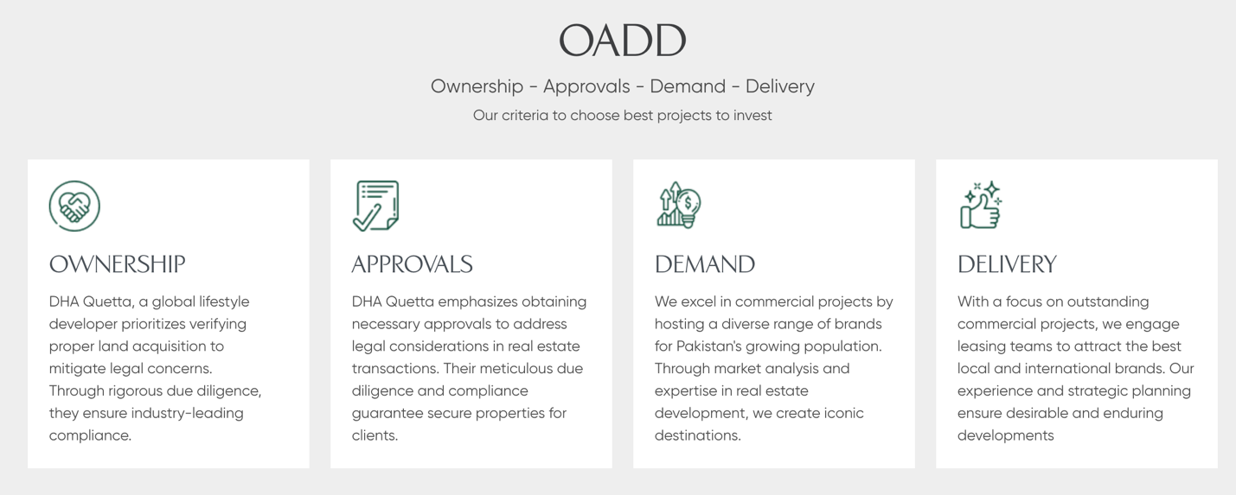

***(Why DHA Is Different)***

* A one section which includes why DHA is different from other societies. 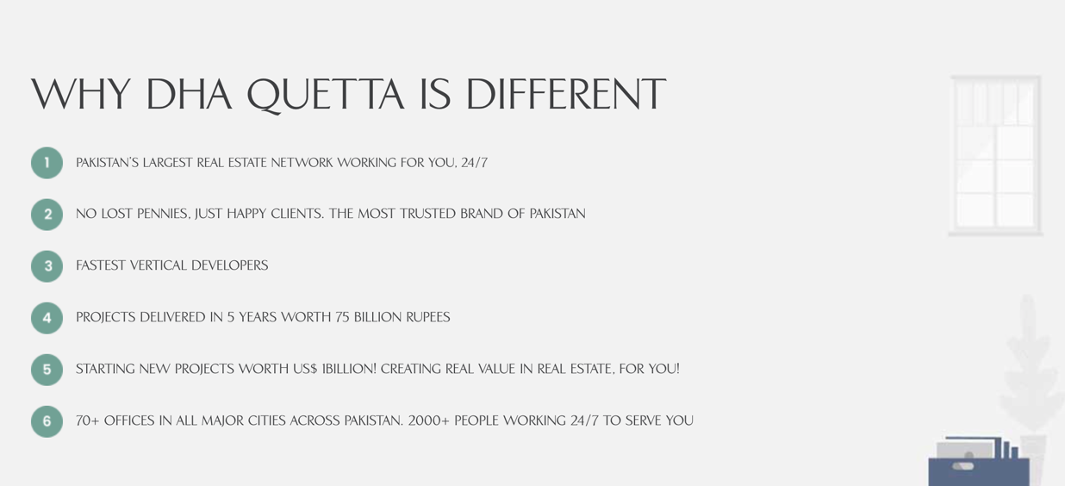

***(SUSTAINABILITY)***

1. Social Page

-Here it may contain listings of community work for example blood drives done, monthly cycling campaigns, Real estate diploma campaigns, Awareness campaigns, sports & arts clubs etc.

1. Governance Page

* management system and processes are duly certified by the standard ISO 9001. We understand that apart from accountable management systems, good governance in any entity further solidifies through the strength of its culture, values, and principles. DHA Quetta holds fast to the profound values of Integrity, Respect, Reliability, Innovation, and Drive to create a fair corporate culture.

1. Environment page

* DHA Quetta is committed to reduce its carbon footprint, enhance its eco-friendly portfolio, and advance towards an evolving sustainable business model. From holistic Environmental Impact Assessment Studies of our project sites to collection of environmental and ecological baseline data and thorough Environmental.

***(DEVELOPMENTS)***

* This may include recent and old projects done by DHA Quetta. Such as a 3-D model or a high-definition picture of the Head office and Hanna Mall.
* Card based Layout would be optimum for the design, as it provides a clear understanding to the viewer.

***Investment***

* This dedicated page is very important as it will be only about latest land allocation, plot prices, any discounts offered, construction offers, and other discounts. The content on this page will mostly by of numerical nature starting with infographic of already sold DHA plots.

***LIFE AT DHA***

* Here we don’t only outline DHA Quetta but DHA itself. DHA itself is a brand and maintaining quality is a must, we can show how people from different locations living in DHA are satisfied, a short video from all DHA locations including DHA Quetta.

***Latest News/Press Releases***

* Here we can educate people how DHA Quetta works. How it has been maintaining millions of people. We can link every user Gmail and use it as a source of communication and delivery of new projects.

***Blog Posting***

* Here we can post the latest editorial and writes about developments and social collaborations. This will be highly effective and precise writeup with authentic use of keywords that will also boost our website ranking and social media foot print.

***Career Page***

* Update about latest vacancies and tender.

***Footer***

* A section where we link every social media, terms of use & private policy.